PROJECT COMPLETION REPORT
IoT Based Environmental Security Monitoring

Student Name: Sahira Bibi
Reg ID: 67859
Course: Information Security
Supervisor: Maam Kiran Fatima
Submission Date: May 4, 2026

- Executive Summary

This project was executed to establish a secure data acquisition pipeline using an ESP32 micro-controller and a DHT22 sensor. The implementation focused on hardware stability (direct wiring) and software interactivity via Serial communication, ensuring high data integrity for environmental monitoring.

- Technical Setup & Hardware

The system was configured with the following parameters to ensure reliable performance: MCU: ESP32 Dev Module connected via COM5. Sensor: DHT22 (High Precision) (Digital Data Output). Wiring: Direct jumper connections to GPIO 4 to minimize signal noise encountered during breadboard testing. Firmware: Developed in C++ using the DHT sensor library and Serial UART protocol at 115200 bps.

3. Observed Environmental Data

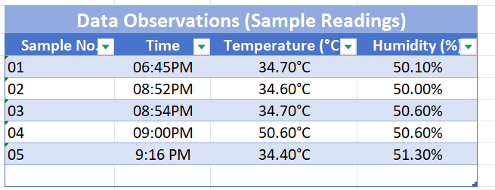

4.Troubleshooting & Debugging

Several technical challenges were addressed during development: Communication Errors:
Resolved "Windows Error 31" by terminating concurrent Serial Monitor sessions.
Input Logic: Configured Serial Monitor to "Newline" setting to allow the readStringUntil('\n') function to process user commands.
Data Validation: Implemented isnan() checks to handle potential sensor disconnects gracefully.

5. Interactive Handshake
To demonstrate two-way communication, the firmware was programmed to respond to specific user inputs. Sending the string "hi" through the Serial Monitor triggers a verification message, confirming the system's active and responsive state.

- Conclusion
--
The project successfully met all technical objectives under the guidance of Ma'am Kiran Fatima. The ESP32 is capable of precise data logging and interactive feedback, making it a viable solution for real-world environmental security applications.

Reading proves

06:45 PM

08:52 PM

08:54 PM

09:00 PM

09:16 PM

Components

